**“E-KETHA” : ENRICHING RICE FARMER’S QUALITY OF LIFE THROUGH A MOBILE APPLICCATION.**

Project Id

Project Proposal Report

Salika Madhushanka W.J

B.Sc. (Hons) Degree in Information Technology

Department of Computer Science and

Software Engineering

Sri Lanka Institute of Information Technology

Sri Lanka

January 2022

**“E-KETHA” : ENRICHING RICE FARMER’S QUALITY OF LIFE THROUGH A MOBILE APPLICCATION.**

Project Id

Project Proposal Report

Salika Madhushanka W.J – IT19101620

Supervisor: Mr. Adeepa Gunarathna

Co Supervisor: Ms. Amali Upeka Gunasinghe

B.Sc. (Hons) Degree in Information Technology

Department of Computer Science and

Software Engineering

Sri Lanka Institute of Information Technology

Sri Lanka

January 2022

**Declaration, Copyright Statement and The Statement Of The Supervisor**

We declare that this is our own work and this proposal does not incorporate without acknowledgement any material previously submitted for a degree or diploma in any other university or Institute of higher learning and to the best of our knowledge and belief it does not contain any material previously published or written by another person except where the acknowledgement is made in the text.

|  |  |  |
| --- | --- | --- |
| Name | Student ID | Signature |
| Salika Madhushanka W.J | IT19101620 |  |

The supervisor/s should certify the proposal report with the following declaration.

The above candidates are carrying out research for the undergraduate Dissertation

under my supervision.

------------------------------ ------------------------------

Signature of the supervisor: Date:

------------------------------ ------------------------------

Signature of the supervisor: Date:

**ABSTRACT**

In our country of Sri Lanka, rice is the most common type of food that is consumed in a daily basis. Due to that rice farmers face a huge amount of stress to supply according to the massive demand. One of the main problems rice farmers are currently facing is the abundance of pests and diseases that affect the rice crops. Due to some of these being highly transmittable, proper action has to be taken quickly and efficiently. Since diseases and pests coming in various types, identifying and treating them can be difficult for the common farmer. The aim is to develop a mobile application that will help farmers solve this particular problem. The application will use images to conduct image processing to analyze and identify the type of disease and pest. This will finally allow machine learning and deep learning to provide the proper solution.

Keywords :- machine learning, image processing, deep learning

**Introduction**

As the most common food in Sri Lanka rice holds a special place in all Sri Lankan’s hearts. Specially for this reason the rice demand is massive. Once of the reasons this demand is not currently met is the destruction of rice crops by diseases and pests.

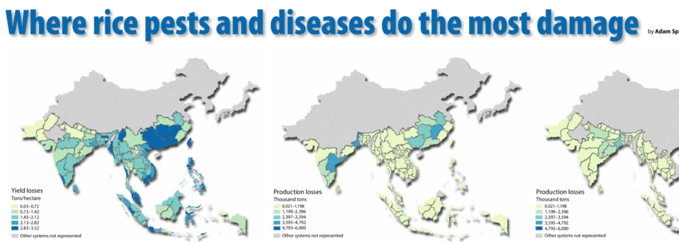

As it is shown in the above diagram in the country of Sri Lanka, the yield losses due to discases and pests are mostly in the red zone. Because of this annually 35% of yield goes to waste.

If these diseases or pests are not treated properly they can spread quickly to other crops making them unhealthy as well. Since there are many types of diseases and pests is virtually impossible for common farmer to have the knowledge about proper pesticide and treatments.

As a solution for all these issues a mobile application will be proposed.